**OBJECT**

Creation of Attendees Object

|  |  |
| --- | --- |
| Team Id | AD47707C5D4D5109D5E480002BDB30D50 |
| Project Tittle | Build an Event Management System using salesforce |

1.click on the gear icon and then select Setup.

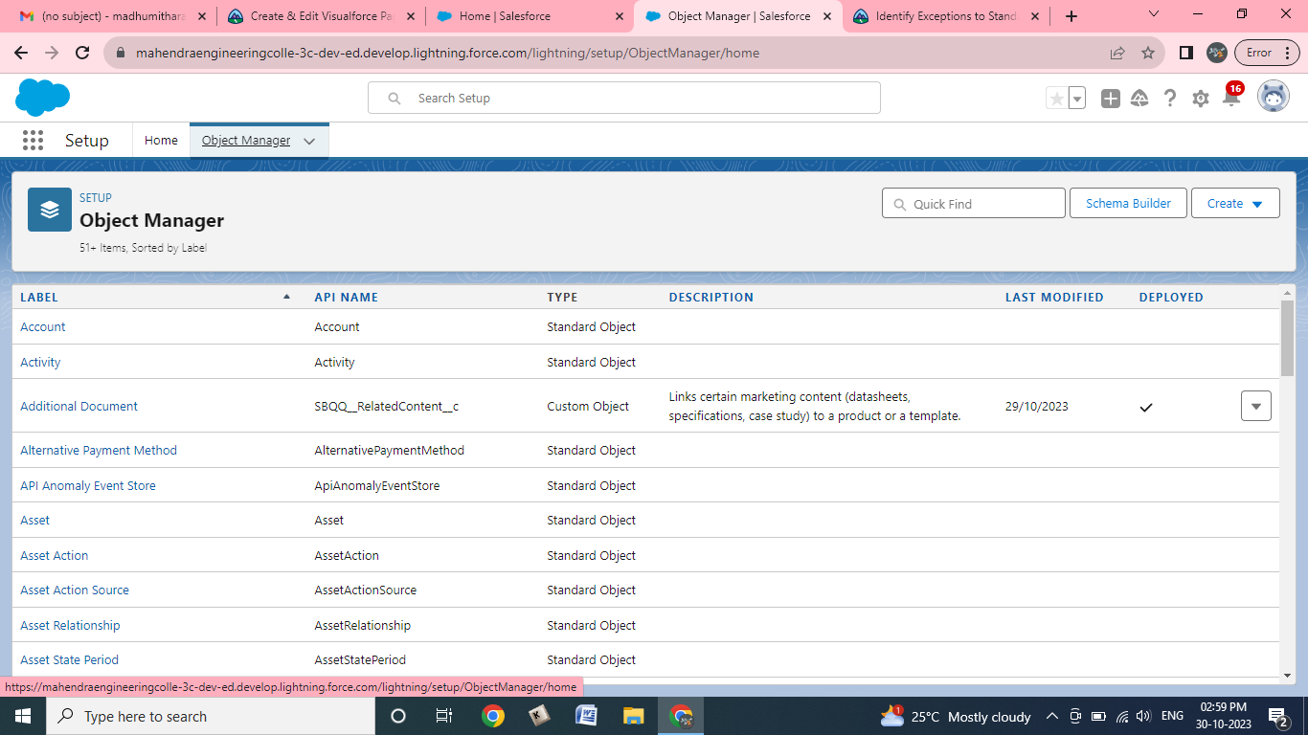

**2.Click on the object manager tab just beside the home tap**

**3.After the above step,have a look on the extreme right you will find a create Dropdown click on that and select Custom Object.**

**a.create the object**

**b.Label:Attendee**

**c.Plural label:Attendees**

**d.Record name:Attendee Name**

**e.check the allow Reports**

**f.check the Allow Search checkbox**

**g.click save**

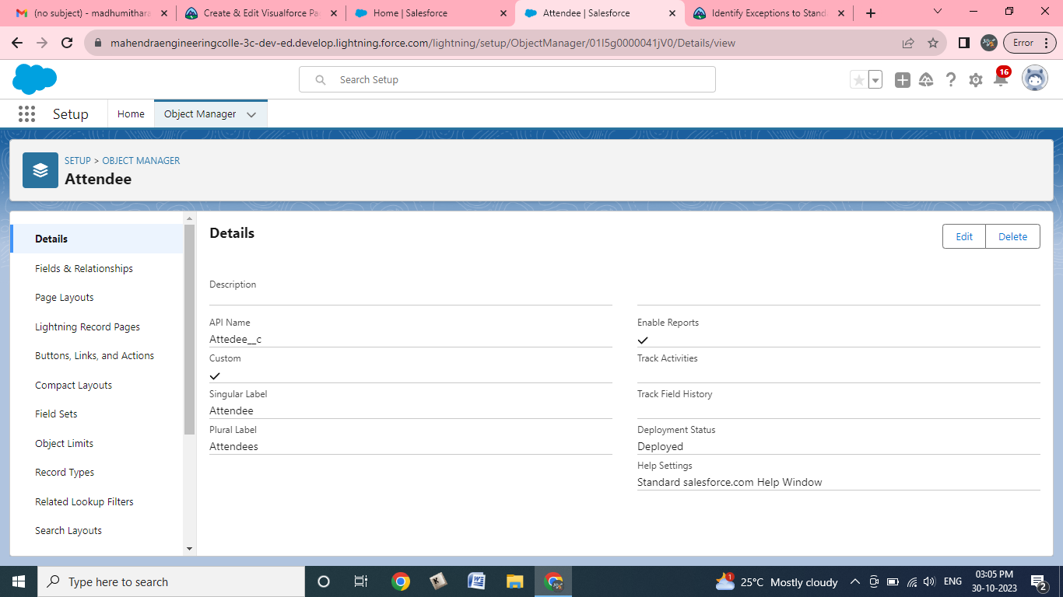

**OBJECT**

Creation of Attendees Object

|  |  |
| --- | --- |
| Team Id | AD47707C5D4D5109D5E480002BDB30D50 |
| Project Tittle | Build an Event Management System using salesforce |

1.click on the gear icon and then select Setup.

